Monitor the WLC_PORTFOLIO_2.0/_Cross_Technology/CCNA_Unified/CCNA/v1.0/v1.0/ELT_Videos/CCNA100_25-7_Monitor_The_WLC_001.mp43Play Transcript ID4180818template_version4.1.1_PORTFOLIO_2.0/_Cross_Technology/CCNA_Unified/CCNA/v1.0/v1.0/ELT_Videos/CCNA100_25-7_Monitor_The_WLC_001.vtt

* You will examine the Monitor menu on the left side of the screen. As you can see, there are several options and many of these options have sub-options denoted by a triangle. At the top of the menu, you see Summary. If you are in one of the lower menus and you want to return to the main screen that has the image of the WLC and click **Summary**.

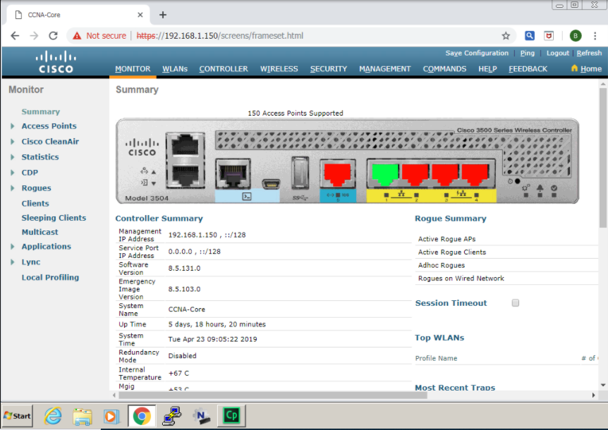

**Procedure1:**

First, you will explore Statistics. Click the triangle next to Statistics. Several new options will appear. At this point, the focus is on the top three options: Controller, AP Join, and Ports. Click the **Controller** option.

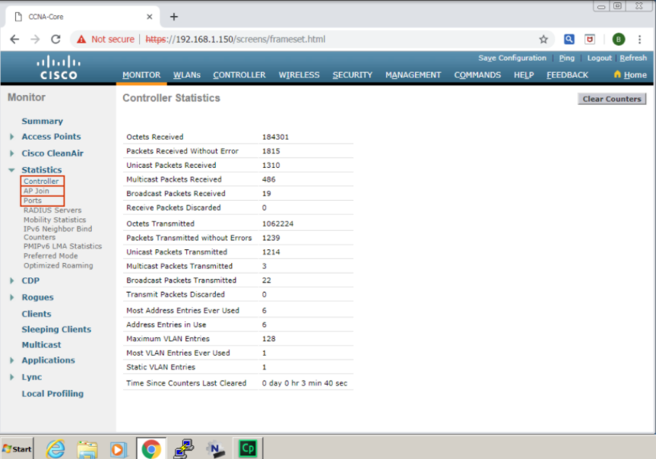You will now see the Controller Statistics screen. This screen captures the network traffic coming into and going out of the controller. This screen is mainly divided into three sections. The Octets Received area, the Octets Transmitted area, and the bottom six individual statistics. In the Octets Received and Transmitted sections, you can see the number of octets transmitted and received, the number of packets transmitted and received without error, multicast packets transmitted and received, broadcast packets transmitted and received, and received and transmitted packets discarded. Notice that there is a difference between the number of received packets and the number of transmitted packets in the Octets Received and Transmitted areas. The reason is that there are no clients on the network yet. This traffic is background traffic that is received and transmitted by the controller.

Look at the bottom of the screen where you can see six more parameters that are being tracked. The first is Most Addresses Ever Used. This value is the highest number of Forwarding Database Address Table entries that have been learned by this controller since the most recent reboot. The Address Entries in Use value is the number of learned and static entries in the Forwarding Database Table for this controller. The Maximum VLAN Entries value is the maximum number of VLAN allowed on this controller. The Most VLAN Entries Ever Used value is the largest number of VLANs that have been active on this controller since the last reboot. The Static VLAN Entries value is the number of presently active VLAN entries on this controller that have been statically created. The Time Since Counters Last Cleared value is the elapsed time in days, hours, minutes, and seconds since the statistics for this controller were cleared.

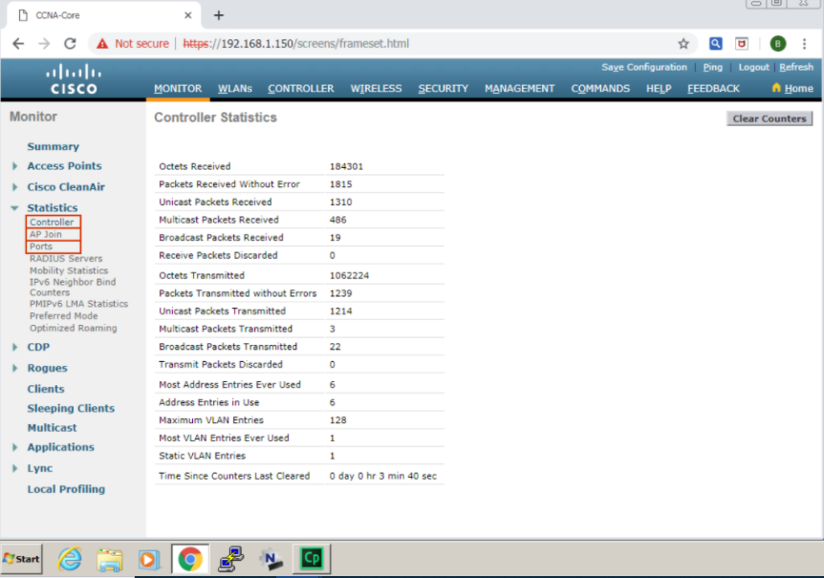

**Procedure2:**

The next step is to clear the counters.

CLOSE TIP

Go to the upper right part of the screen and click **Clear Counters**.

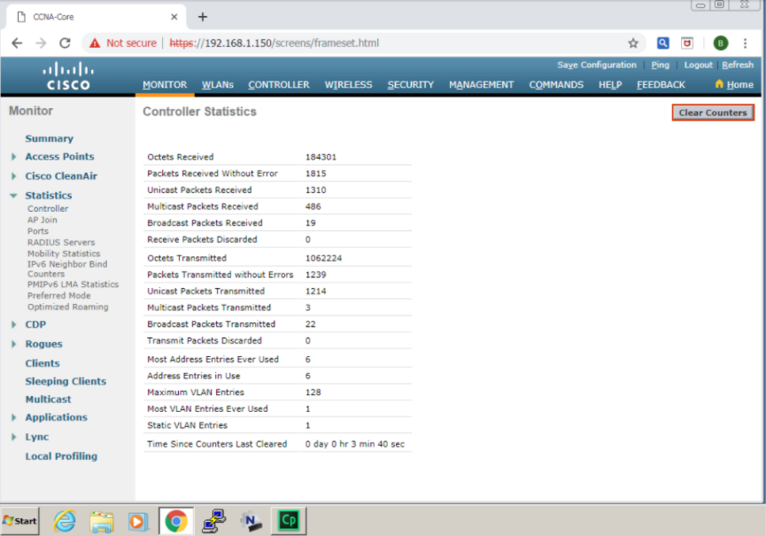

You will see the screen change to the state shown below.

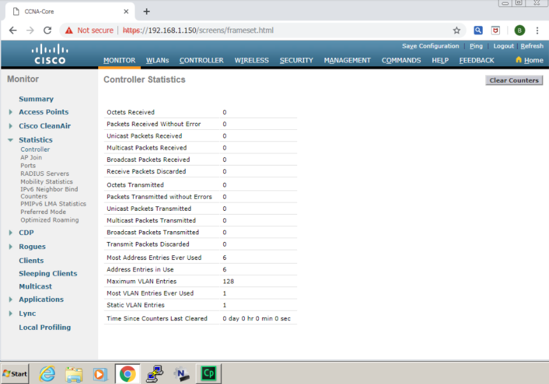

**Procedure3:**

Navigate to the menu bar on the left, and click the **AP Join**option.

CLOSE TIP

A new screen will appear. It provides a list of currently joined APs.

As you can see, this view is organized by the following parameters:

* **AP Base Radio MAC**
* **AP name:** Choosing a descriptive name makes locating an AP with a problem in the facility a lot faster and easier.
* **Status of the AP:** Shows the current join status for this AP.
* **Ethernet MAC:**MAC address of the Ethernet port on the AP
* **IP address:**This feature is very helpful if the AP is getting an IP address in the wrong VLAN and you have been getting user complaints about failing to join the WLAN.

Normally you would use the scroll bar on the bottom of the screen to examine all of the fields; in this simulation you will use the **Next** button to see this information.

* **Last Join Time:** Last on the far right, you see statistics about the Last Join Time. This information can be very useful if you have an AP that is joining and leaving the controller constantly. The Last Join Time will usually be relatively recent, but you may see APs that have a Last Join Time that was weeks or months ago.

The last item in this view is the blue box at the end of the entry for this AP. If you hover the mouse over this box, the Remove option appears. There may be times when you need to remove an AP from a controller. The Remove option is a quick way to perform that task.

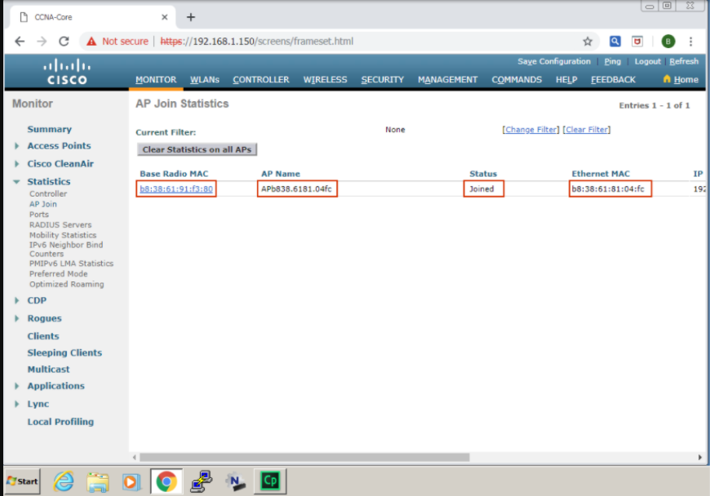

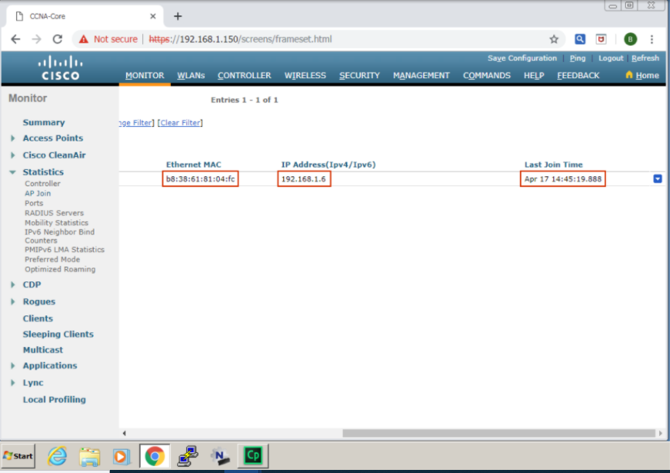

**Procedure4:**

Go back to the left menu bar and click the **Ports** option.

CLOSE TIP

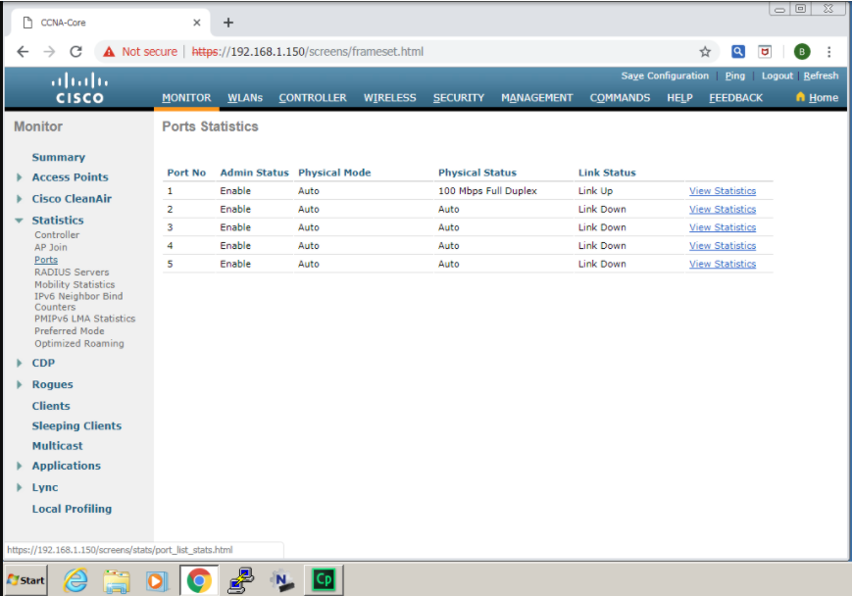

You will see a new screen. As you can see, there are entries for the five ports on the controller. There is one Multigigabit (mGig) port and four Gigabit Ethernet ports. It might seem counter-intuitive, but the first port in the list is the first Gigabit Ethernet port and the last is the mGig port. Each port lists the Admin Status, Physical Mode, Physical Status, and Link Status. This overview makes it really easy to see a problem with one or more ports. At the end of each port output, there is the View Statistics option.

The listed ports are the physical ports on the device that you can see in the next figure. You are already familiar with it from the Monitor Summary screen. The colors show the condition of the switch ports in the WLC. One of the ports is marked with green. This port is the one that we use in this discovery to connect to a LAN switch and is also the one that you saw in the previous screen at the top of the port list with the state **Link** **Up**.

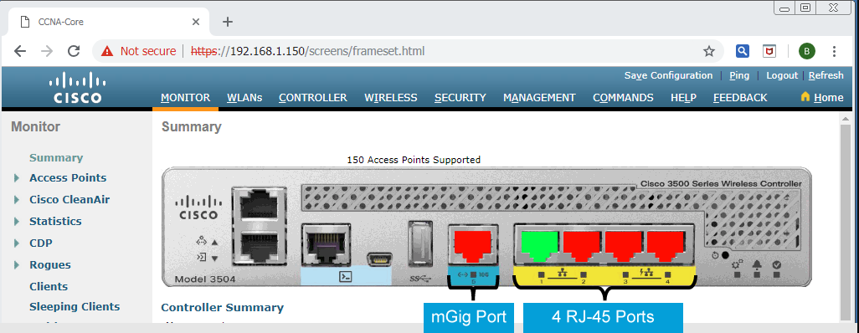

**Note**

Each WLC has several ports, (physical interfaces) and several logical interfaces. Multiple logical interfaces can be assigned to one physical port. You can see the ports in the device picture on the Monitor Summary screen of the WLC GUI. You will encounter the logical interfaces and learn more about their role in the next discovery. The ports and the interfaces together ensure the proper operation of the WLC and enable its integration with the network.

**Procedure5:**

Click **View Statistics** for Port 1.

CLOSE TIP

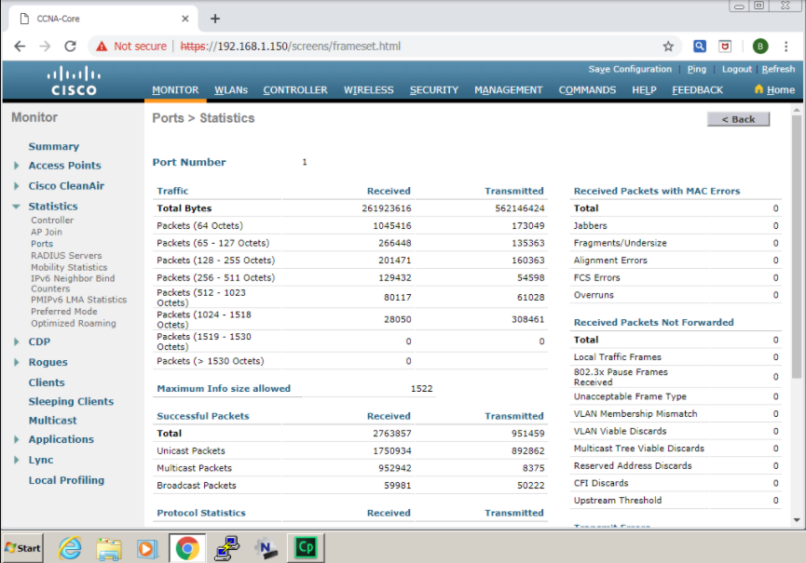

Now, you see a much different set of statistics available for the port. Take a minute to look at the different areas in this output. Notice the Traffic area. This area provides the total number of octets of data (including the octets in bad packets) received on the network (excluding framing bits but including Frame Check Sequence [FCS] octets). This object can be used as a reasonable estimate of Ethernet utilization. Normally you would use the scroll bar on the bottom of the screen to examine all of the fields; in this simulation, you will use the **Next** button to see the rest of information.

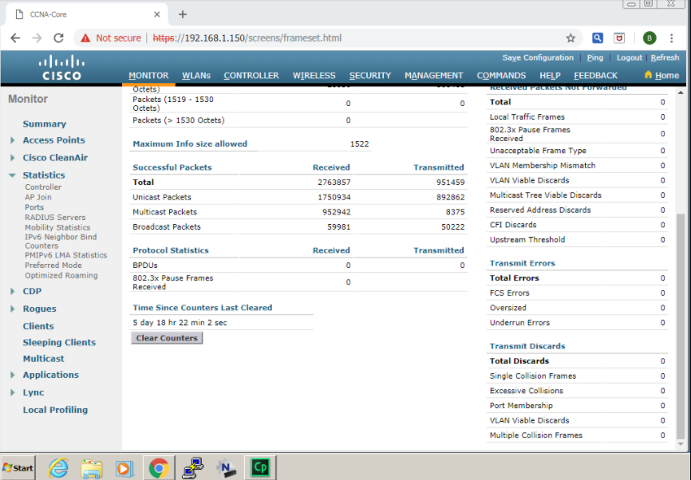

Observe the Maximum info Size Allowed field. This field shows the maximum size of the info (non-MAC) field that this port receives or transmits. Below is the Successful Packets field, which is broken down to Unicast packets, Multicast Packets, and Broadcast packets.

**Procedure6:**

You have completed this activity when you have attained these results:

* You have explored the menu bar on the left side of the Monitor Summary Screen.
* You have opened and explored the Statistics menu option.
* You have explored the Controller, AP Join and Ports menu options.